**TABLE OF FIGURES**

Page

Figure 1 : Cloud Computing Applied to Chemical Analysis       9

Figure 2 : Team collaboration system for mobility water monitoring 17

Figure 3 : Iterative Model 21

Figure 4 : Proposal Report 24

Figure 5 : Progress Report 1 25

Figure 6 : Progress Report 2 26

Figure 7 : Progress Report 3 27

|  |  |  |  |  |  |  |  |
| --- | --- | --- | --- | --- | --- | --- | --- |
| **Document Name** | **Detail** | | **Status** | **Date** | **Viewable** | **Reviewer** | **Responsible** |
| **Documents** | | | | | | | |
| Proposal_V0.1.docx | | - Add Chapter1  - Introduction & Background  - Add Chapter2  - Business Review  - Technology Review | Draft | 10-02-2014 | PP,  WT | PP,  WT | PP,  WT |
| Proposal_V0.2.docx | | - Adjust Chapter1  - Introduction & Background  - Adjust Chapter2  - Technology Review  - Development Tool Review | Draft | 15-02-2014 | PP,  WT, SW | PP,  WT | PP,  WT |
| Proposal_V0.3.docx | | - Adjust Chapter3  - Quality Standards  - Add Chapter4  - Project Plan  - - Add Chapter5  - References | Draft | 17-02-2014 | PP,  WT | PP,  WT | PP,  WT |
| Proposal_V0.4.docx | | - Adjust Chapter1  - Introduction & Background  - Add Chapter4  - Add Chapter5 | Draft | 24-02-2014 | PP,  WT, SW | PP,  WT | PP,  WT |
| Proposal_V1.0.docx | | - Proposal | Released | 05-03-2014 | PP,  WT, SW | PP,  WT | PP,  WT |
| Proposal_V1.1.docx | | - Update project proposal | Draft | 25-03-2014 | PP,  WT, SW | PP,  WT | PP,  WT |
| Proposal_V2.0.docx | | - Proposal | Released | 26-03-2014 | PP,  WT, SW | PP,  WT | PP,  WT |

**Document History**

**\* PP = Mr.Peerapong Chompootepa**

**\* WT = Mr.Worrasete Tansurat**

**\*SW = Ms.Siraprapa Wattanakul**

Table of Content

**Chapter 1-1 | Introduction and Background** 7

**Chapter 1-2 | Literature Review** 8

2.1 Business Review 8

2.1.1 Overview 8

2.2 Technology Review 10

2.2.1 PHP 10

2.2.2 Android 10

2.2.3 Google Maps 11

2.2.4 Google Cloud SQL 11

2.3 Development tools Review 12

2.3.1 Eclipse with ADT 12

2.3.2 ADT Plug-in for Eclipse 12

2.3.3 Android SDK 13

2.3.4 Adobe Dreamweaver 13

2.3.5 XAMPP 14

**Chapter 1-3 | Quality Standard** 15

3.1 ISO29110 for Very Small Entity (VSE) 15

**Chapter 1-4 | Project Plan** 16

4.1 Motivation 16

4.2 Aims and Objective 16

4.2.1 Aim 16

4.2.2 Objective 16

4.3 System Architecture 17

4.4 Deliverables and Limits 18

4.4.1 Deliverables 18

4.4.2 Documents 20

4.4.3 Limits 20

4.5 Future work 20

4.6 Software Development Life Cycle 21

4.6.1 Iterative Model 21

4.7 Schedule & Milestone 22

4.7.1 Proposal Report 24

4.7.2 Progress Report 1 25

4.7.3 Progress Report 2 26

4.7.4 Progress Report 3 27

**Chapter 1-5 | References** 28

# 

# Chapter 1-1 | Introduction and Background

The chemical analysis of the water quality could be difficult to measure because water is a wide network of branching like rivers, creeks, swamps, etc. Water in each location can contain vividly different levels of pollution. Water quality issues do not influence only environmental but also affect human health. Monitoring can help to recognize and prevent pollution problems.

In the process of the water monitoring, collectors are assigned to go to the selected locations and collect the samples of water. After that, they go back to the laboratory for evaluating the water quality. However, the problem is that if the distance of selected locations is too far from the laboratory, the condition of chemical components in the collected sample may change overtime. Consequently, the result of water analysis may not accurate and unreliable. It would be a waste of time as well for collectors to go to the sites to collect the samples and repeat the same procedure again and again.

Currently, I-ANALY-S-T, the research center of the faculty of science of Chiang Mai University has developed a mobile application which supports the chemical analysis regarding the water quality. The application can record the test value result of the water sample at the survey point to the GoogleSQL without taking back to the laboratory. However, this application can be used as standalone application which does not support the user identification. The test result cannot share instantly. The application does not provide the central system to integrate the test result, manage team and manage the location for the collector to do the water sampling.

Team collaboration system for mobility water monitoring is the idea to increase the value of the water monitoring process to have more efficiency. The system can share the information of the team members which is controlled by the team leader. The team leader can create a location and assigns the responsibility of the team members in each point on the map. Therefore, the collector is unnecessary to ask the team leader about his responsibility in the project. The application can help the team leader to trace all of the collectors to prove that they actually do the water sampling. The system can make further convenience of the connection between team leader and team members. The prompt message can be sent to each other in a bidirectional way, if the team leader needs his team member to recollect the water sampling. In this project, the developers determine to create team collaboration system on both web application and mobile application and also extended functions of the existing mobile software to have further completion for team collaboration.

# Chapter 1-2 | Literature Review

## 2.1 Business Review

### 2.1.1 Overview

There are many different ways to keep track of monitoring the water quality. In the past, whenever where the collectors need to measure the quality of water source, they have to go outside to collect some water sampling of the target area. The problem is the center does not know the results of monitoring at that time. Carrying the water sampling from field to the laboratory spends too many times. The element of the water can change can change before you arrive to the laboratory if the survey area is far. The reason leads to develop the application to analyze and evaluate the water quality.

Center of Excellence for Innovation in Analytical Science and Technology (I-ANALY-S-T) has developed the modern chemical analysis for water quality using the technology in chemical analysis combines with the modern information technologies, which can check the quality of water sources rapidly by considering the water quality indices, namely (pH), temperature, conductivity, (Do), (Turbidity), (TDS), the nitrate, ammonia, phosphate and the (COD).

Although, there is technology on mobile application, I-ANALY-S-T found the difficult to trace back the water sampling from the collectors. We do not know that the collectors actually collect the water sampling of the target area. So that, the solution of this problem is to create a new system cover the team collaboration of one water sources using more than one collector collect water sampling to look for the various area in each of water sources. The system can solve the problem of using mobile to monitor water source on another area.

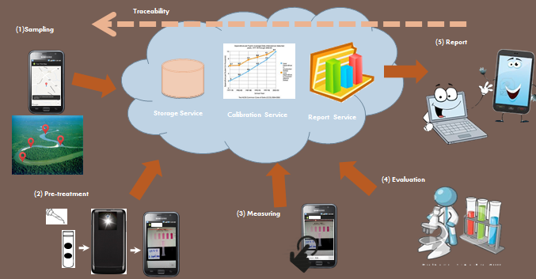

**Figure 1 :** Cloud Computing Applied to Chemical Analysis

Referring to Figure 1, Cloud Computing Applied to Chemical Analysis consists of (1) Sampling, (2) Pre-treatment, (3) Measuring, (4) Evaluation, and (5) Report.

The step (1) to step (3) is developed by I-ANALY-S-T. For the first step, Sampling, the application offers the main feature for identifying the location of the sampling site. Then, the collectors collect the samples to measure the water quality and send the data from the location to the cloud server.

The developers apply the existing software to extend functions and develop new software as a central system to evaluate the measuring results (step 4) and show the test results (step 5).

## 

## 2.2 Technology Review

### 2.2.1 PHP

PHP is an open source server –side scripting language and programming language use on the site. It can be written in a variety of application, as well as the common language. In different from HTML is the language used in the formatting of the website. For the popular website is simple to interact with users with PHP, HTML or JavaScript are used as a control for display purposes only.

Alternative technology

* Visual Basic (ASP.Net)-C#
* JSP
* Python
* Perl
* Ruby
* ColdFusion

The Selection of this technology

        PHP is one of the most popular server sides scripting language running today. It is used for creating dynamic web page that interact with the user offering customized information. PHP offers many advantage. It is fast, Stable, secure, easy to use and open source (free).

### 2.2.2 Android

Android is an operating system with Java programming language for the electronic devices that include operating system such as smart phones and tablet. Android is requiring the Android Software Development Kit or  Android SDK provides all necessary tools to develop Android application. This includes compilers, debugger and device emulator. It is own virtual to run Android programs

Alternative technologies

* BlackBerry OS from RIM

iOS from Apple, Inc.

* Symbian OS from Nokia and Accenture
* Window Phone from Microsoft
* Linux based on operating system
* Palm OS by Palm, Inc.

The Selection of this technology

* Android is a free open source operating system for embedded devices.
* An open source development platform for creating applications.
* Devices, particularly mobile phones that run the Android operating system and the application created for it.
* We can find a lot of tutorials and the Android plugin for Eclipse

### 2.2.3 Google Maps

        Google Maps is a map on the internet to help you find a location or route roughly in travel and can be used with navigation system GPS. Google Maps satellite images are not updated in real time, but rather they are several months or years old. [1]

Alternative technologies

* Yahoo! Map Web Services
* MM Map API
* Amazon Maps API

The Selection of this technology

Google API package, it can create map-based Activities using Google Maps as a user interface element. It has full access to the map, which enables to control displays settings, after the zoom level, and pan to a different location. Using Overlays and it can annotate maps and handle user input. (John Wiley & Sons, Inc. 2012)

### 2.2.4 Google Cloud SQL

Google Cloud SQL is currently available for Google App Engine applications that are written in Java, Python, PHP, and Go. You can also access Google Cloud SQL using MySQL Client, and other administration and reporting tools that work with MySQL database. [2]

The Selection of this technology

You can access a familiar, highly available SQL database from your App Engine applications, without having to worry about provisioning, management, and integration with other Google services.

## 2.3 Development tools Review

### 2.3.1 Eclipse with ADT

Eclipse is an integrated development environment (IDE). It contains a base workspace and an extensible plug-in system for customizing the environment. Written mostly in Java, Eclipse can be used to develop applications. By means of various plug-ins, Eclipse may also be used to develop applications in other programming languages: Ada, C, C++, COBOL, Fortran, Haskell, JavaScript, Lasso, Perl, PHP, Python, R, Ruby (including Ruby on Rails framework), Scala, Clojure, Groovy, Scheme, and Erlang. It can also be used to develop packages for the software Mathematica. Development environments include the Eclipse Java development tools (JDT) for Java and Scala, Eclipse CDT for C/C++ and Eclipse PDT for PHP, among others. [3]

Alternative technologies

* NetBean IDE
* IntelliJ IDEA
* Notepad++

The Selection of this technology

The advantage of the Eclipse software is easy to install J2SDK and available on all versions. Eclipse support for many languages are used to enhance the performance of the plugin. It can work with multiple file types such as HTML, Java, C, JSP, EJB, XML, and GIF, and more importantly it is free of Orleans. It is compatible with operating systems Windows, Linux and mac OS. [4]

### 2.3.2 ADT Plug-in for Eclipse

Android Development Tools (ADT) is a plugin for the Eclipse IDE that is designed to give you a powerful, integrated environment in which to build Android applications.

ADT extends the capabilities of Eclipse to let you quickly set up new Android projects, create an application UI, add packages based on the Android Framework API, debug your applications using the Android SDK tools, and even export signed (or unsigned) .apk files in order to distribute your application. [5]

Alternative Tool

* App Inventor

The selection of this tool

* As the recommended development platform, using Eclipse with the ADT plug-in for Android development offer some significant advantage, primarily through the tight integration of many of the Android build and debug tools into IDE. (John Wiley & Sons, Inc. 2012)

### 2.3.3 Android SDK

The Android SDK (software development kit) is a set of development tools used to develop applications for Android platform. The Android SDK includes the following:

* Required libraries
* Debugger
* An emulator
* Relevant documentation for the Android application program interfaces (APIs)
* Sample source code
* Tutorials for the Android OS

The selection of this tool

* The programmer can use Android SDK to develop application and test it on the emulator which similar to the real Android phone
* Android SDK provides a great starting point for an individual developer of Android code. It is missing features that facilitate the collaboration and coordination needed when a team develops an Android application by integrating the device-specific, native platform SDK with a compatible commercial development solution, agile teams can achieve tremendous efficiencies and higher-quality results. [6]

### 2.3.4 Adobe Dreamweaver

Adobe Dreamweaver is a proprietary web development tool developed by Adobe Systems. Dreamweaver was originally developed by Macromedia in 1997, and was maintained by them until Macromedia was acquired by Adobe Systems in 2005.

Adobe Dreamweaver is one of the most popular professional web development software packages. Dreamweaver is a complex product suitable for everything from simple page design to development of dynamic pages written with ColdFusion, PHP, ASP, CSS, XML, XSLT, and JavaScript. [7]

The selection of this tool

* Adobe Dreamweaver provides the tools to help create web pages that have high flexible.
* Adobe Dreamweaver supports for various scripting languages​​, both client and server, such as Java, ASP, PHP, CGI, VBScript.
* Adobe Dreamweaver provide the tools to the upload page to a server for perform publish the work that we create on the internet.
* -Adobe Dreamweaver supports multimedia such as sound, video files to insert, use in conjunction with Flash, Fireworks.

### 2.3.5 XAMPP

XAMPP is a free and open source cross-platform web server solution stack package, consisting mainly of the Apache HTTP Server, MySQL database, and interpreters for scripts written in the PHP and Perl programming languages. [8]

Alternative Tool

* Appserv
* WampServer

The selection of this tool

The good thing about XAMPP; it is free, easy to install, and no configuration is needed to make APACHE, PHP & MYSQL compatible with each other.

# Chapter 1-3 | Quality Standard

## 3.1 ISO29110 for Very Small Entity (VSE)

        ISO29110 is a guide applies to a very Small Entity (VSE), enterprise, organization, department or project up to 25 people, dedicated to software development. The Guide provides Project Management and Software Implementation process which integrate practices base on the selection of ISO/IEC 12207-Systems and Software Engineering – Software Life Cycle Process and ISO/IEC15289 Software Engineering – Software Life Cycle Process – guideline for the content of software life cycle process information product (documentation) standards element.

**Project Management process**

        The purpose of the project Management process is to establish and carry out in a systematic way the task of the software implementation project, which allows complying with the project’s objective in the expected quality, time and cost.

Selected process

1. Project Planning Process

2. Project Plan Execution Process

3. Project Assessment and Control Process

4. Project Closer Process

**Software Implementation process**

        The purpose of the Software Implementation process is the systematic performance of the analysis, design, construction, integration and tests activities for new or modified software products according to the specified requirement.

Selected process

1. Software Implementation Initiation Process

2. Software requirement Analysis Process

3. Software Architectural Design Process

4. Software Construction Process

5. Software Integration and test Process

6. Software Delivery Process Chapter

# Chapter 1-4 | Project Plan

## 4.1 Motivation

Normally, the water quality measuring need to be collected in various locations. The existing application can be used in only once a times and cannot processes the data into the center which cause wasting it wastes the time. The reason leads developers to develop the application to solve the problem. Team collaboration system for mobility water monitoring application able to send the data to center directly and also able to prompt the user since there are some problems. These are the advantages to reduce the time for working.

## 4.2 Aims and Objective

### 4.2.1 Aim

The aim of this project is to develop the mobility water monitoring system in order to manage the team project and share test information to the working team.

### 4.2.2 Objective

* To create the central system support team collaboration
* To help managing project teams
* To help identifying the collectors responsibility
* To help sharing all test results aggregated to the evaluation
* To be able to trace back the test result from the research center
* To reduce the time of working as a team

## 

## 4.3 System Architecture

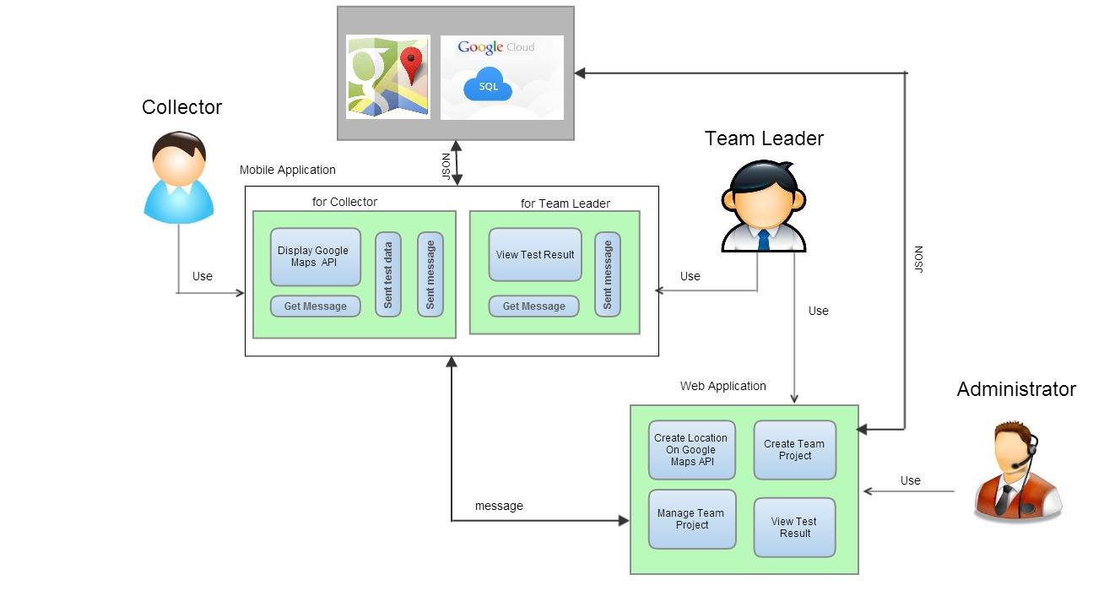

**Figure 2**:Team collaboration system for mobility water monitoring

Figure 2 show the overview of Team collaboration system for mobility water monitoring system. There are 3 parts in the system consist of Mobile Application for Collector, Mobile application for team leader and Web application for admin and the team leader. Mobile Application for Collector is the existing software which the collector tests the sample of water and send the test result to the GoogleSQL. Mobile Application for Team Leader provides the result presentation which retrieves the test result from the GoogleSQL. Finally, Web Application that provide for Administrator and Team Leader. Administrator can create and manage the team project. Team leader can create the location on Google Maps to collector and view the details of the test result. The message sends to each other between team leader and collector.

## 4.4 Deliverables and Limits

### 4.4.1 Deliverables

There are 3 parts in the system consist of

* **Web application Part (Administrator and Team leader)**
  + Feature#1: Authentication system on web application
  + Feature#3: Project management
  + Feature#4: Map location management
  + Feature#5: Result Presentation
  + Feature#6: Messaging System
* **Mobile Part (Team leader)**
  + Feature#2: Authentication system on mobile application
  + Feature#5: Result Presentation
  + Feature#6: Messaging System
* **Mobile Part (Collector)**
  + Feature#2: Authentication system on mobile application
  + Feature#6: Messaging System
  + Feature#7: Extension of existing application

Each of features is separated as follows:

**Feature#1: Authentication system on web application**

* Admin can log in to the system.
* Admin can log out from the system.
* Admin profile
  + Admin can edit his profile.
  + Admin can change password.
* Admin can approve the registered account from the team members
* Team leader can log in to the system.
* Team leader log out from the system.

**Feature#2: Authentication system on mobile application**

* Team leader can log in to the system.
* Team leader log out from the system.
* Collector can register the system.
* Collector can log in to the application
* Collector log out from the application

**Feature#3: Project management**

* Admin can create the team project.
* Admin and team leader can select the team members into the team project.
* Admin can specify a team leader from all members in the team project.

mgdsgdsgadsgadgadg

* Admin can enable the project
* Admin can disable the project
* Admin can view list of team projects with its members.
* Team leader can remove the team member out of the team project.

**Feature#4: Map location management**

* Team leader can create the location by Google Maps.
* Team leader can assign team member to the location on the map.
* Team leader can change the work assignment of the team members and notify them when they are assigned works.
* Team leader can view the name of team member in each point on the map.
* Using color as a status in each assigned location by red is not complete the test and green is complete the test

**Feature#5: Result Presentation**

* The website connect to GoogleCouldSQL which are the name of testing location, the collector name in each point, latitude and longitude of each position, date and time, and the information each of parameters to retrieve data of test result

**Feature#6: Messaging System**

* Direct messages
  + Team leader can send a message to each of team members one by one.
  + Each of team members can send message to team leader.
* Group messages
  + Everyone in team project can send the message to each other, which is seen by everyone.

**Feature#7: Extension of existing application**

* Modify database structure
* Modify the map of collector mobile to support work assignment from team leader
* Save the test result locally preparing for upload later when the internet is available
* View details of each test result

### 4.4.2 Documents

* Proposal
* Project Plan
* Software Requirement Specification
* Software Design Document
* Testing Document
* Test Plan
* Unit Test Document
* System Test Document
* Test Report
* Unit Test Document
* System Test Document
* 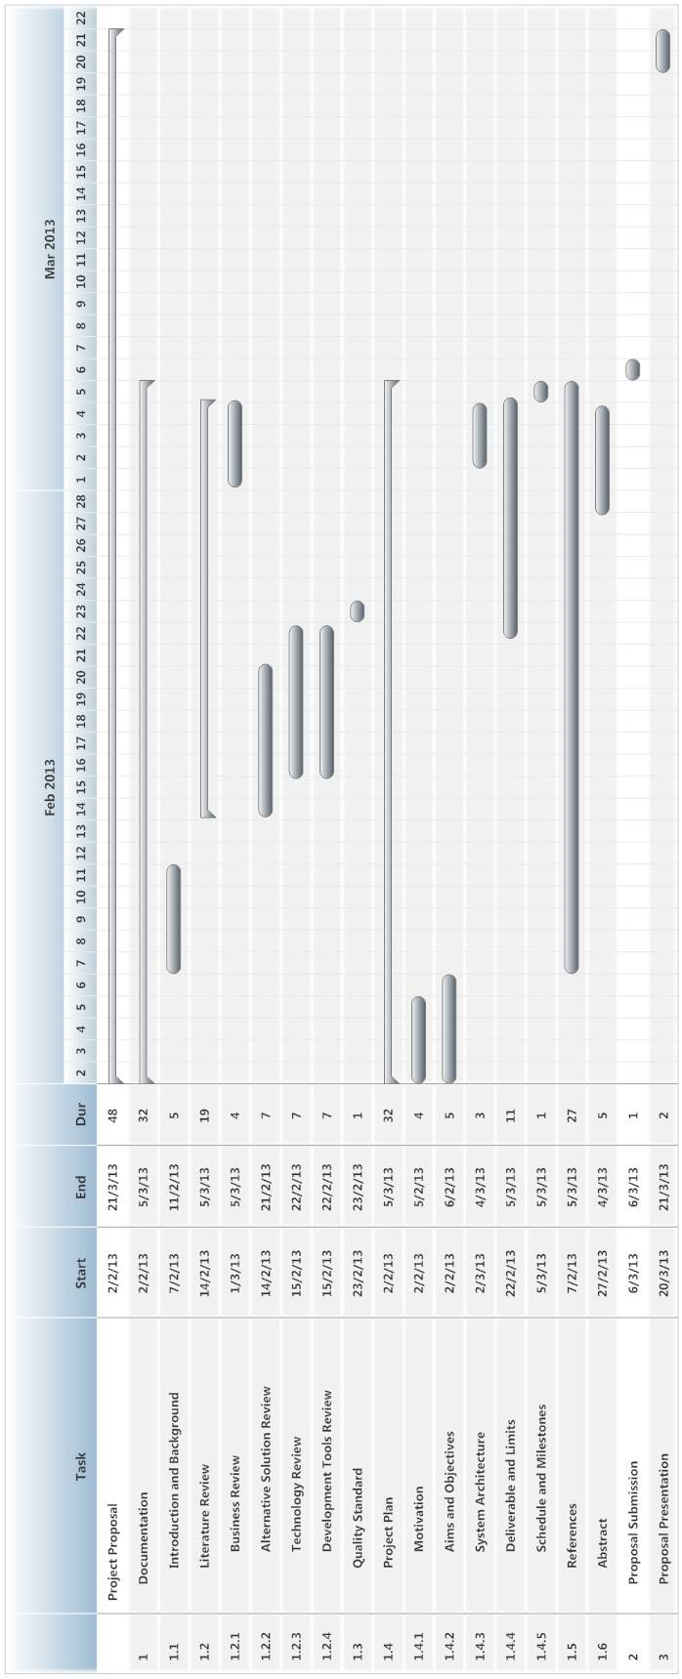Traceability Record
* Progress Status Report
* Self-assessment Report

### 4.4.3 Limits

* The internet connection is required for using this system and application.
* Smart device, which are using Android OS.
* User should have account for access to the system.
* Website support only English language.

## 4.5 Future work

* Team collaboration system for mobility water monitoring application can support with other platform (iOS).

## 4.6 Software Development Life Cycle

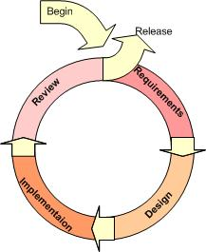

**Figure 3**:Iterative Model [9]

### 4.6.1 Iterative Model

An iterative life cycle model uses the concept of dividing the work into small pieces to reduce the risk of development. The development begins by specifying and implementing just part of the software, which can then be reviewed in order to identify further requirements. During each of iteration, the development module goes through the requirements, design, and implementation and testing phases. Each subsequent release of the module adds function to the previous release. The process continues till the complete system is ready as per the requirement.

An iterative life cycle model can accommodate changes by stakeholder feedback to refine requirements and design. The developers can build and improving the product step by step causes we can track the defects at the early stages.

## 4.7 Schedule & Milestone

|  |  |  |  |
| --- | --- | --- | --- |
| **Milestone** | **Task** | **Milestone Criteria** | **Planned date** |
| 1 | Proposal | -Topic defined | February |
| 2 | Proposal Report | - Proposal reviewed  - Proposal submitted  - Proposal presentation | March |
| 3 | Progress Report 1 | - Software Requirement Specification  - Software Design Document  - Test Plan Progress 1  - Implementation Progress 1  - Test Feature Progress 1  - Traceability Record Progress 1  - Progress  report 1 submitted  - Progress report  1 presentation | May |
| 4 | Progress Report 2 | - Software Requirement  Specification  - Software Design Document  - Test Plan Progress 2  - Implementation Progress 2  - Test Feature Progress 2  - Traceability Record Progress 2  - Progress  report 2 submitted  - Progress report 2 presentation | July |
| 5 | Progress Report 3 | - Software Requirement Specification  - Software Design Document  - Test Plan Progress 3  - Implementation Progress 3  - Test Feature Progress 3  - Traceability Record Progress 3  - Progress  report 3 submitted  - Progress report  3 presentation | October |

The features have separated to 3 progresses as follows:

**Progress Report 1**

* + Feature#1: Authentication system on web application
  + Feature#2: Authentication system on mobile application
  + Feature#3: Project management

**Progress Report 2**

* + Feature#4: Map location management
  + Feature#5: Result Presentation
  + Feature#7: Extension of existing application

**Progress Report 3**

* + Feature#6: Messaging System

### 4.6.1 Proposal Report

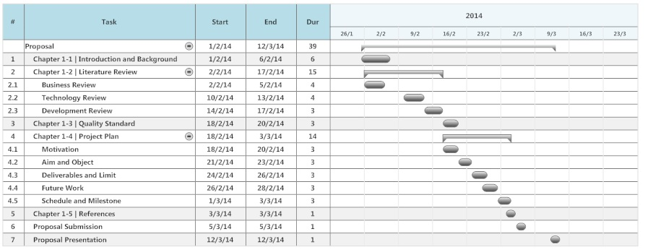

**Figure 4:** Proposal Report

### 4.6.2 Progress Report 1

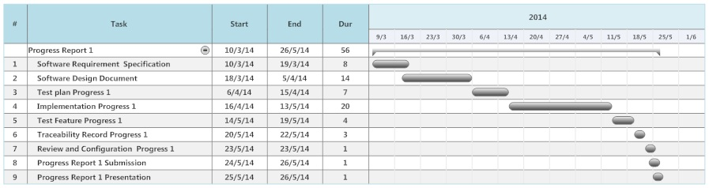

**Figure 5:** Progress Report 1

**Progress Report 1**

* Feature#1: Authentication system on web application
* Feature#2: Authentication system on mobile application
* Feature#3: Project management

### 4.6.3 Progress Report 2

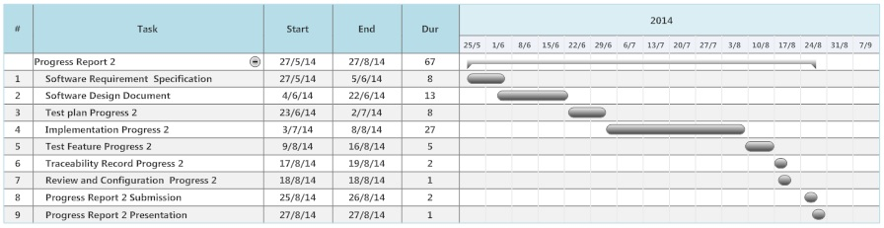

**Figure 6:** Progress Report 2

**Progress Report 2**

* Feature#4: Map location management
* Feature#5: Result Presentation
* Feature#7: Extension of existing application

### 4.6.4 Progress Report 3

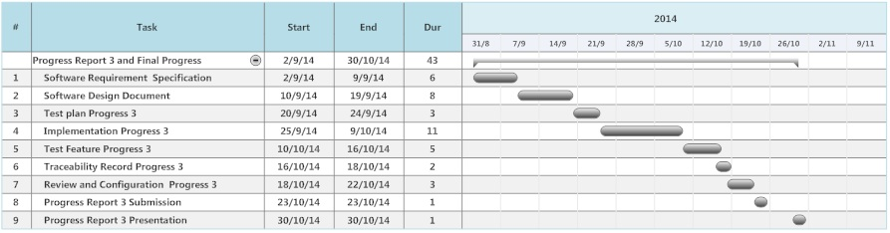

**Figure 7 :** Progress Report 3

**Progress Report 3**

* Feature#6: Messaging System

# Chapter 1-5 | References

**[1] Google Maps**

Author : -

Access on: 2014

Resource : <http://google.wikia.com/wiki/Google_Maps>

**[2] Google Cloud SQL**

Author : Google development team

Access on: 2014

Resource : <https://developers.google.com/cloud-sql/docs/introduction>

**[3] Eclipse with ADT**

Author : -

Access on: 1 March 2014

Resource : <http://en.wikipedia.org/wiki/Eclipse_(software)>

**[4] Advantage of Eclipse with ADT**

Author : Eclipse development team

Access on: 2014

Resource : <http://www.eclipse.org>

**[5] ADT Plug-in for Eclipse**

Author : Eric Cloninger

Access on: 9 May 2012

Resource : <http://marketplace.eclipse.org/content/android-development-tools-eclipse>

**[6] Android SDK**

Author : LEIGH WILLIAMSON

Access on: 11 February, 2011

Resource : <http://embedded-computing.com/articles/the-commercial-eclipse-based-solutions/>

**[7] Dreamweaver**

Author : -

Access on: 2014

Resource : <https://www.ntchosting.com/web-design/dreamweaver.html>

**[8] XAMPP**

Author : -

Access on: 25 February 2014

Resource : http://en.wikipedia.org/wiki/XAMPP

**[9] Iterative Model**

Author : -

Access on: 25 February 2014

Resource : <http://www.snyders.us/qa-iterative.htm>l